

Faculty of Business and Technology
ITE354 – Business Intelligence and Decision Modeling
Supermarket Analytics Dashboard

Submitted by (Group Members):

Kaung San Thar (2211020004)
Kaung Si Thu (2211090003)
Htet Myat Naing (2209120005)
Naing Min Khant (2209230006)
Course Instructor: Atikom Srivallop
Submission Date: 20-Feb-2026

Abstract
This project presents the development of an interactive Supermarket Analytics Dashboard using Microsoft Power BI. The objective is to analyze sales performance and provide clear insight into managerial decision-making. The dataset includes transactional information such as order date, sales, profit, product categories, customer segments, location data, and returns. The data was cleaned and transformed into Power Query, modeled using relationships (including a Date table for time-based analysis), and analyzed using DAX measures. The final dashboard highlights overall performance through card visuals, compares current performance with previous year results, and provides breakdowns by category, state, and customer segment. The dashboard also includes a mobile layout for better accessibility on smartphones.

Contents
1. Introduction 5
2. Data and ETL Process 6
2.1 Dataset Overview 6
2.2 Extract — Importing Data 6
2.3 Transform (Power Query) 6
Step 1: Change Data Types 7
Step 2: Creating Date Columns 7
Step 3: Data Cleaning and Transform Steps 7
Step 4: Load Data 8
3. Data Model and Calculations 8
3.1 Data Model (Relationships) 8
3.2 DAX Measures 8
4. Dashboard Design and Analysis 10
4.1 Performance Summary (Card Visuals) 10
4.2 Sales vs Previous Year (Trend Analysis) 11
4.3 Profit by Category and Sub-Category 12
4.4 Profit by State (Map Visualization) 12
4.5 Sales by Segment 13
4.6 Final Dashboard 13
4.7 Mobile Layout 14
4.8 Interactive Slicer Panel (Bookmark Feature) 15
5. Difficulties or Problems 16
6. Future Improvements 17
7. Discussion and Conclusion 17
8. References 18

1. Introduction
Business Intelligence tools help organizations transform raw data into useful insights. In supermarket operations, analyzing sales and profit trends supports better decisions related to product strategy, customer targeting, and regional performance improvement.
This project focuses on developing an interactive dashboard that provides insights into supermarket sales performance. The dataset is sourced from Kaggle, containing transactional records with attributes such as date, sales, profit, category, state, segment, and returns.
This project focuses on building an interactive dashboard that enables users to:
- Monitor total sales and profit,
- Track return rate,
- Compare current results with previous year (PY),
- Analyze profit by product category and sub-category,
- Analyze geographic performance by state,
- Compare performance across customer segments,
- View a mobile-friendly version of the dashboard.
Microsoft Power BI was used for data modeling, transformation, and visualization.

2. Data and ETL Process

2.1 Dataset Overview
The dataset contains key fields such as:
- Order Date
- Sales
- Profit
- Category / Sub-Category
- Segment
- State / Region
- Return information
This dataset provides a comprehensive view of supermarket sales performance.

2.2 Extract — Importing Data
The dataset was downloaded from Kaggle and imported into Power BI.
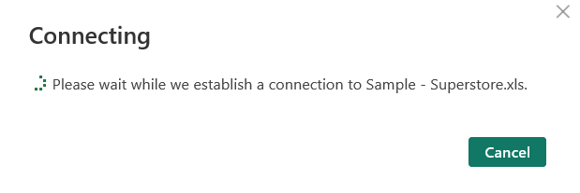
Figure 1: Importing the supermarket sales dataset using Power BI’s Get Data feature.

2.3 Transform (Power Query)
Power Query Editor was used for cleaning and preparing the dataset before analysis.

Step 1: Change Data Types
The Order Date column was converted to Date format. Numeric fields such as Sales and Profit were verified and formatted appropriately to support correct calculations.

Step 2: Creating Date Columns
Additional date columns were created to support analysis, including:
- Year
- Month
- Start of Month
These fields support time intelligence calculations and monthly trend visuals.
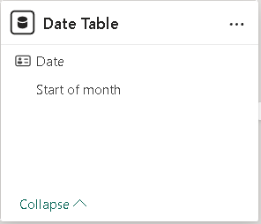
Figure 2: Created Year, Month, and Start of Month columns in Power Query.

Step 3: Data Cleaning and Transform Steps
The Applied Steps panel was used to verify each transformation step. Data issues (such as blanks or formatting inconsistencies) were checked and resolved as needed to ensure stable visuals and measures.

Step 4: Load Data
After confirming that transformations were applied correctly, the data was loaded into the Power BI model using Close & Apply.

3. Data Model and Calculations

3.1 Data Model (Relationships)
A Date Table was used to support time intelligence functions. Relationships were created between the Date Table, Orders, and Returns.
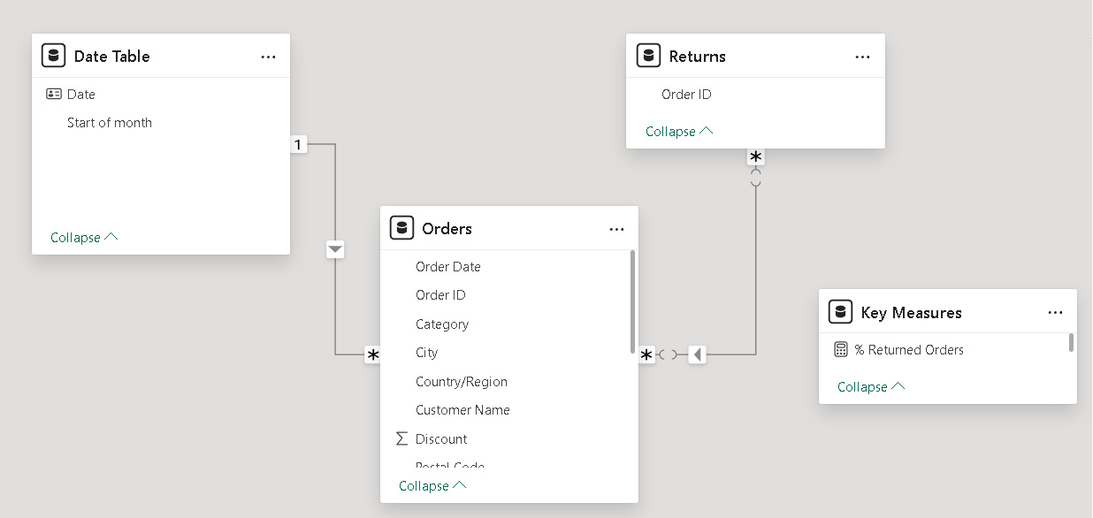
Figure 3: Relationships between Date Table, Orders, and Returns.

3.2 DAX Measures
Measures were created to calculate business performance metrics and comparisons, including:
- Total Sales
- Total Profit
- Sales PY (Sales Previous Year)
- Profit PY (Profit Previous Year)
- % Returned Orders
Time intelligence was implemented using a Date table and DAX functions to compare current period performance to the previous year.
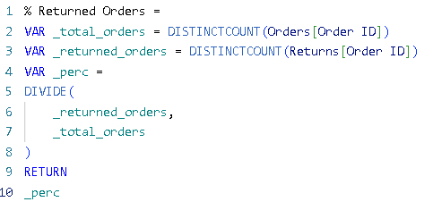
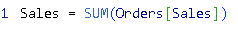
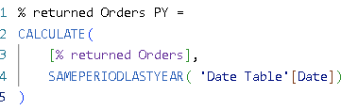
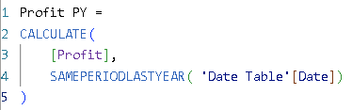
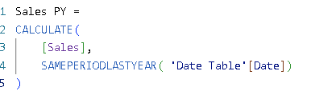
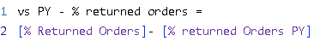
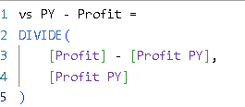
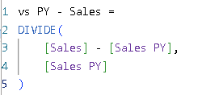
Figure 4: List of DAX measures in the Power BI Measures pane.

4. Dashboard Design and Analysis
The dashboard was designed with manager-focused visuals.

4.1 Performance Summary (Card Visuals)
Card visuals were used to display key performance indicators:
- Total Sales
- Total Profit
- % Returned Orders
- Previous Year comparison values
These provide a quick, high-level summary for managers.

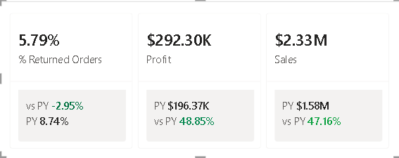
Figure 5: Card visuals showing Total Sales, Total Profit, % Returned Orders, and PY comparison.

4.2 Sales vs Previous Year (Trend Analysis)
A line chart was used to compare Sales with Sales PY by month. This helps identify seasonality, growth patterns, and performance changes over time.
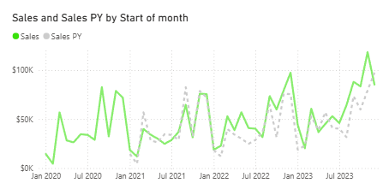
Figure 6: Sales vs Sales PY comparison line chart.

4.3 Profit by Category and Sub-Category
A bar chart was used to analyze profit by product category and sub-category to identify which product groups contribute most to profitability.
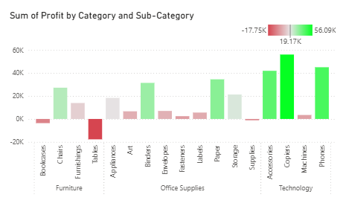
Figure 7: Profit by category and sub-category visualization.

4.4 Profit by State (Map Visualization)
A map visual was used to show profit distribution across states. This supports regional analysis by highlighting strong and weak areas.
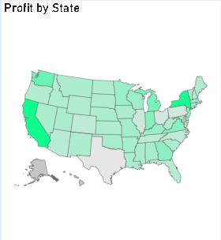
Figure 8: Map visualization showing profit distribution across states.

4.5 Sales by Segment
A visual was created to compare Sales across customer segments. This supports customer-focused decision-making and targeting.
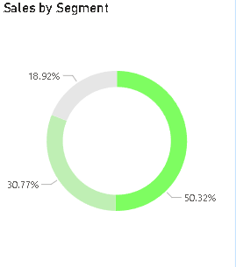
Figure 9: Sales distribution by customer segment.

4.6 Final Dashboard
All visuals were arranged into a single dashboard page for interactive analysis using filters and cross-highlighting.
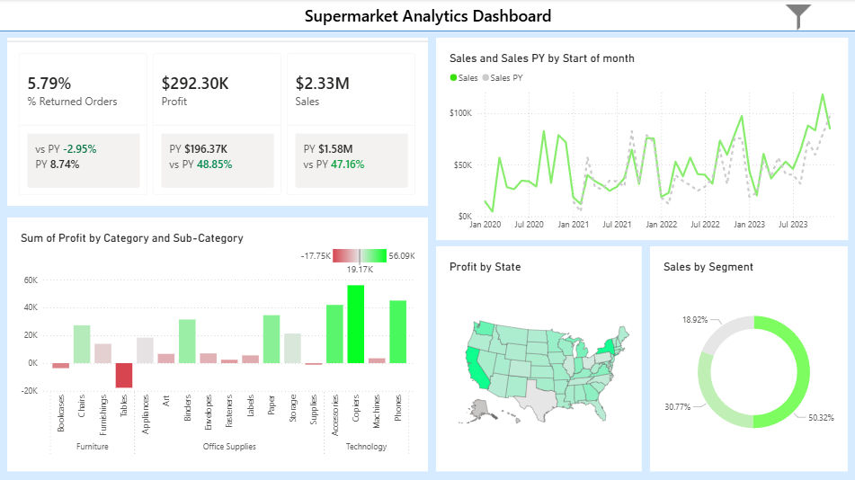
Figure 10: Completed Supermarket Analytics Dashboard.

4.7 Mobile Layout
A mobile layout was designed to improve readability on smartphones. Visuals were rearranged vertically to support easy scrolling and quick performance checking.
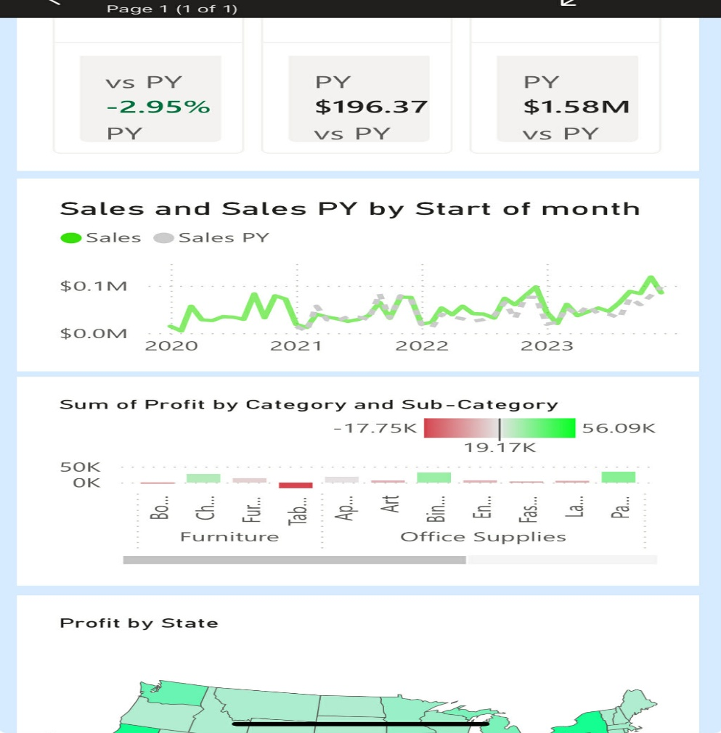
Figure 11: Power BI Mobile Layout of the dashboard.

4.8 Interactive Slicer Panel (Bookmark Feature)
To improve dashboard usability and maintain a clean layout, an interactive slicer panel was implemented using the Selection Pane and Bookmark feature in Power BI.
A filter icon was created to allow users to open and close the slicer panel dynamically. Two bookmarks were configured:
• Pane Open – Displays the slicer panel
• Pane Close – Hides the slicer panel
The Selection Pane was used to control the visibility of the slicer group. The Bookmarks feature was then used to store the visibility states. The filter icon was connected to the bookmarks using the Action property (Type: Bookmark).
This approach improves user experience by reducing visual clutter while allowing users to filter data when needed.
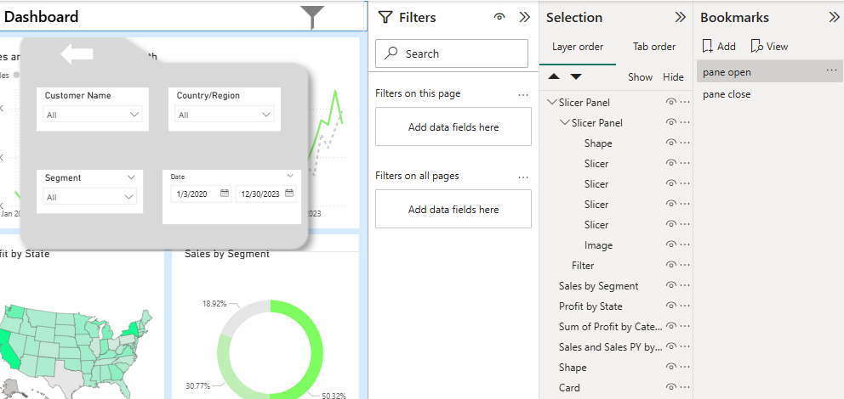
Figure 12: Interactive Slicer Panel Using Selection and Bookmark Feature

5. Difficulties or Problems
During the project, challenges included:
- ensuring correct relationships between tables for accurate filtering,
- applying time intelligence calculations for previous year comparisons,
- resolving measured errors (such as incorrect blanks),
- designing a clean layout for both desktop and mobile views.
- implementing bookmark toggle functionality for the slicer panel and ensuring correct visibility settings and action configuration.
These issues were solved through testing, adjusting the model, and refining DAX measures.

6. Future Improvements
Future improvements could include:
- adding forecasting for sales trends,
- adding drill-through pages for deeper category or state analysis,
- incorporating customer-level metrics (repeat purchase, lifetime value),
- integrating real-time refresh or automated updates,
- Adding advanced performance targets and alerts.
These would improve strategic decision support.

7. Discussion and Conclusion
This Supermarket Analytics Dashboard demonstrates the power of Power BI in transforming raw data into actionable business insights. Through effective visualizations and calculated metrics, it provides managers with a clear understanding of performance trends, profitability, and segment-level behavior.
The dashboard supports data-driven decision-making, enabling business managers to monitor key performance indicators and identify opportunities for improvement.
Overall, this project met the goals of the assignment and delivered a professional interactive report that is useful for managerial analysis.

8. References
1. Kaggle (2024). Supermarket Sales Dataset. https://www.kaggle.com

